**Assignment 7.2**

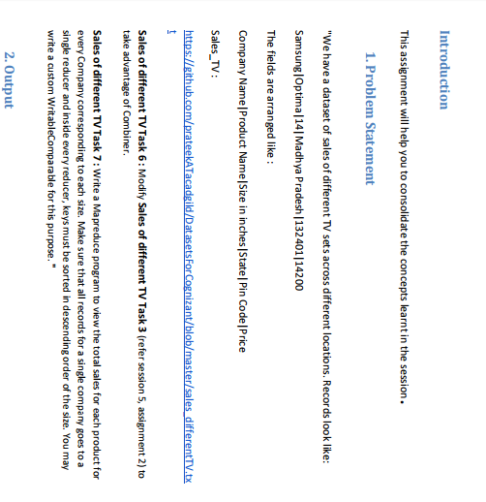

**Input file**

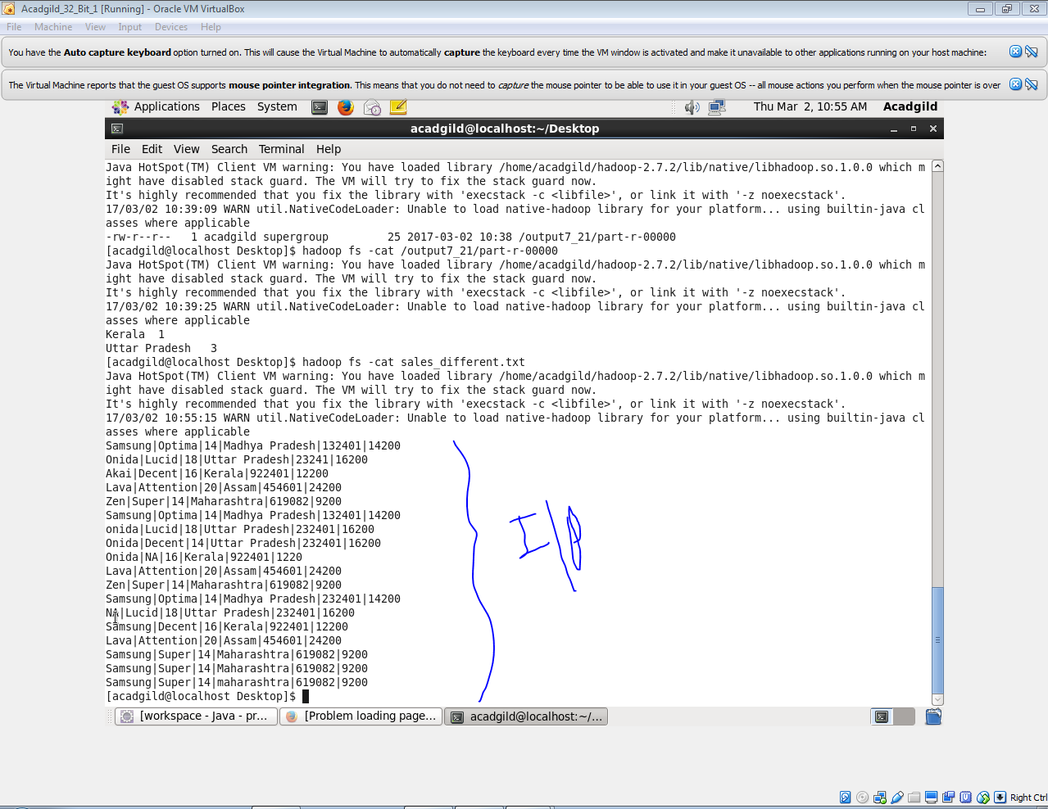

**Task 6:**

**Code**

**Driver**

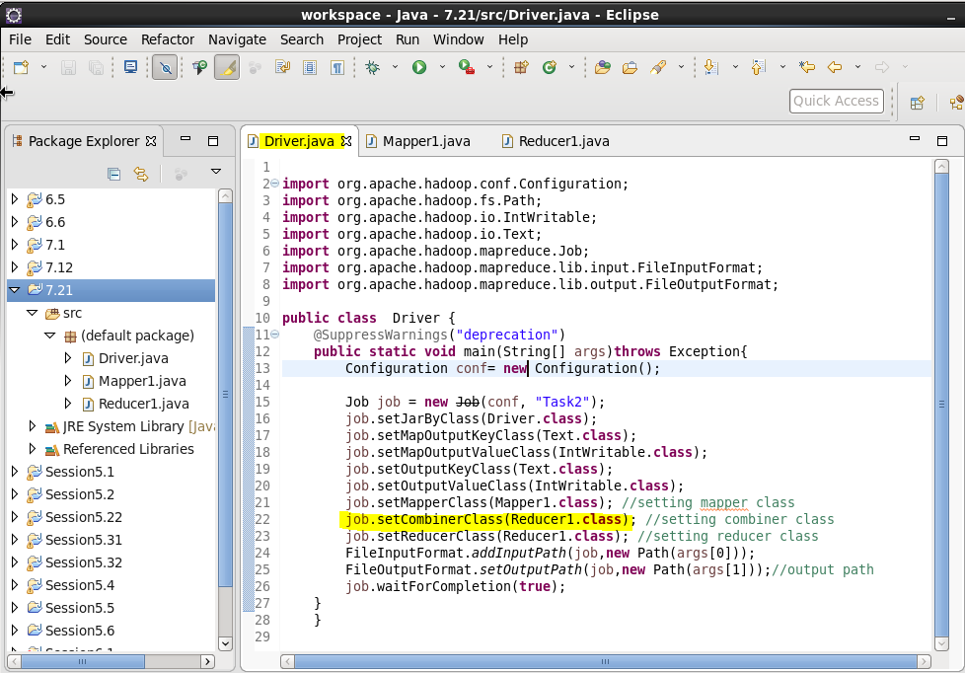

**Mapper**

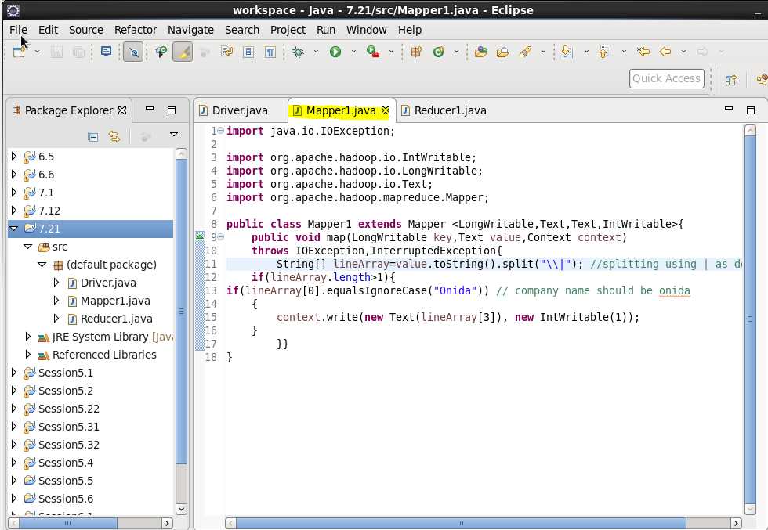

**Reducer**

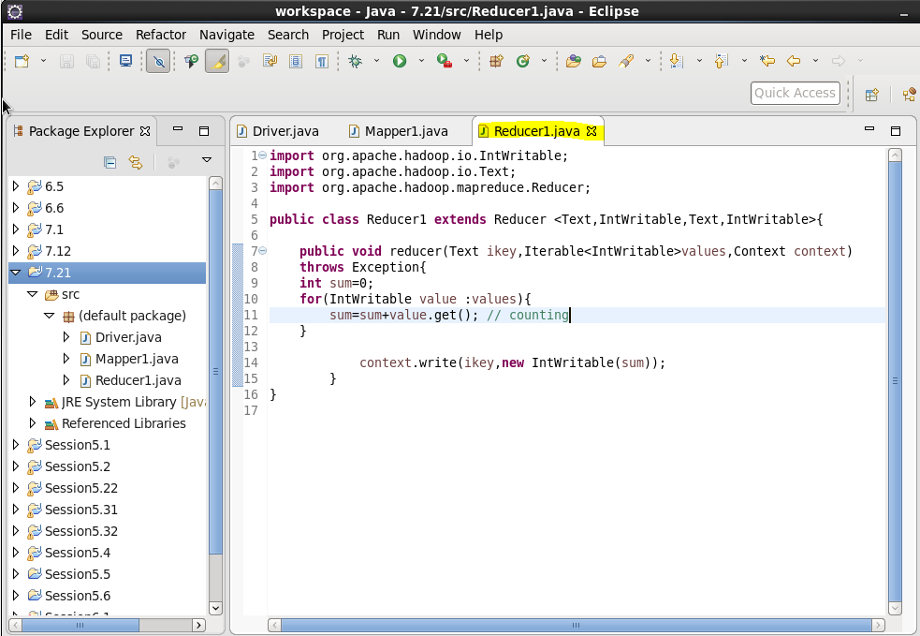

**Output**

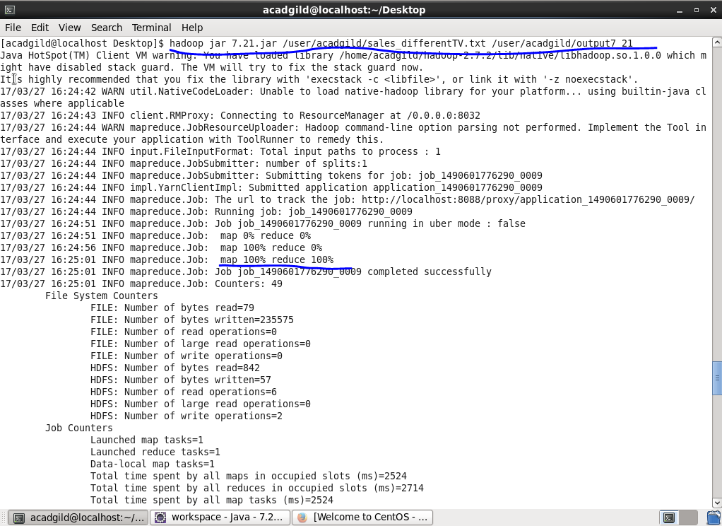



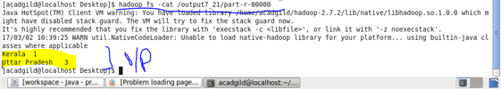

**Task 7 :**

**Driver**

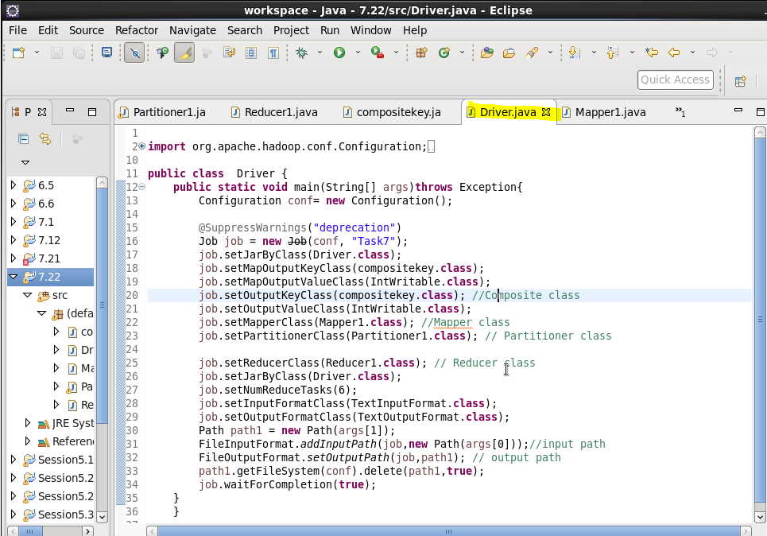

**Mapper**

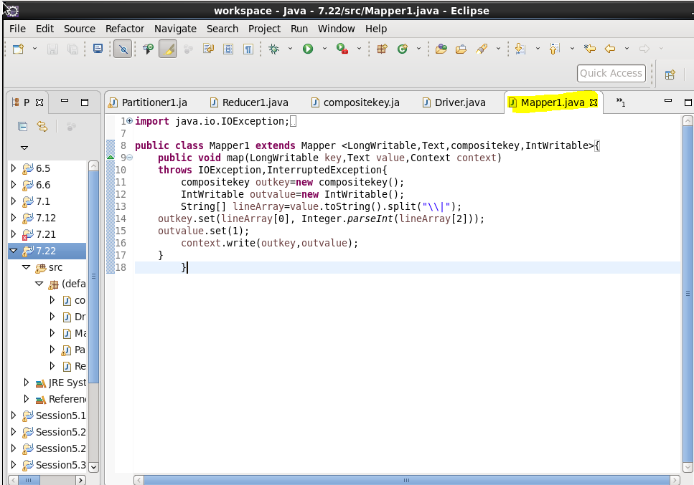

**Reducer**

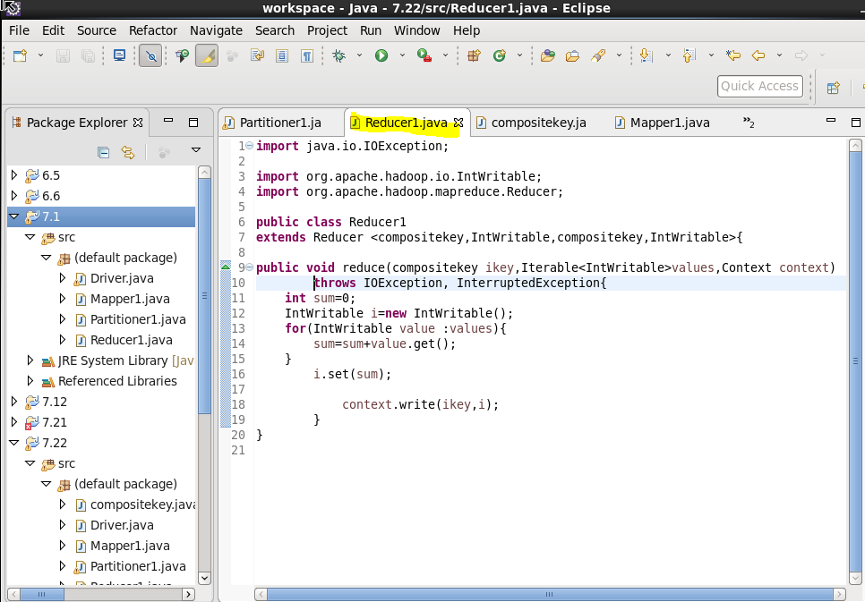

**COMPOSITE KEY**

* OVERRIDING AND HASHCODE OF COMPANY
* OVERRIDING EQUALS METHOD: CHECKS THE COMPANY AND SIZE ARE EQUAL FOR EVERY OBJECT IF EQUAL IT WILL SEND TO THE CORRESPONDING HASHCODE LOCATION ELSE COMPARE TO WILL BE DONE.
* OVERRIDING COMPARETO METHOD: IF BOTH THE COMPANY ARE EQUAL IF ITS SAME IT WILL RETURN (-1)(SIZE-OBJECT’S SIZE)(**-1 WILL REVERSE THE SORT DESCENDING BASED ON SIZE**) AND IT WILL BE SEND AND FRAMEWORK SORTING WILL BE MADE ON IT OR ELSE IF DIFFERENT IT WILL SEND THE COMPANY AND FRAMEWORK SORTING WILL BE MADE ON IT
* OVERRIDING TOSTRING METHOD TO PRINT THE COMPANY AND SIZE

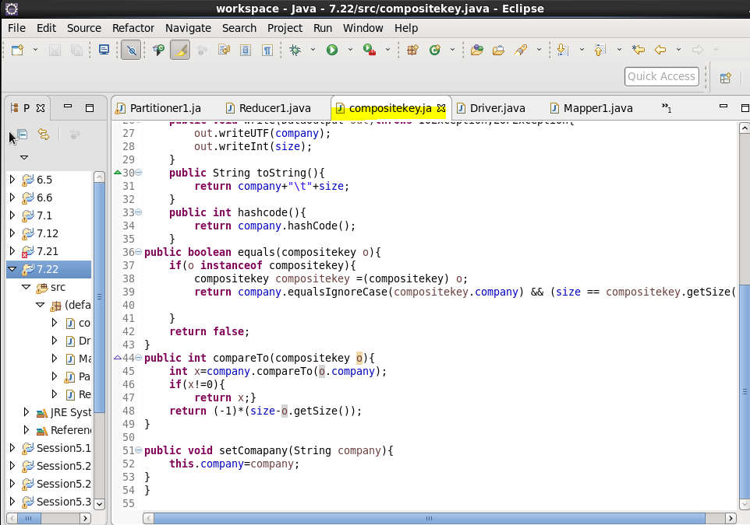

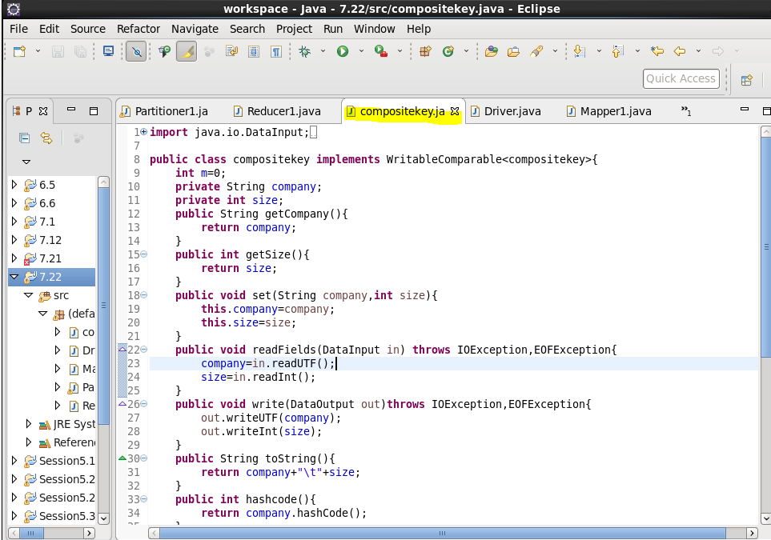

**Partitioner**

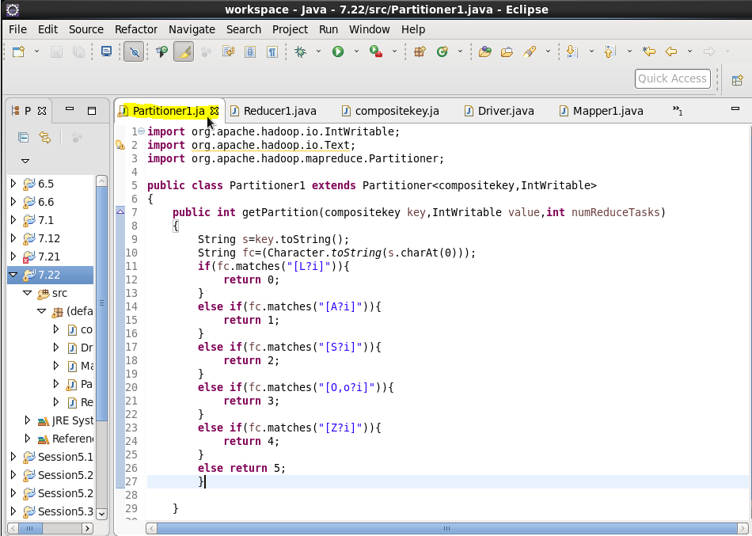

**Jar file:**

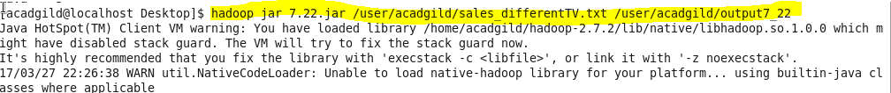

**Output**

